First screenshot :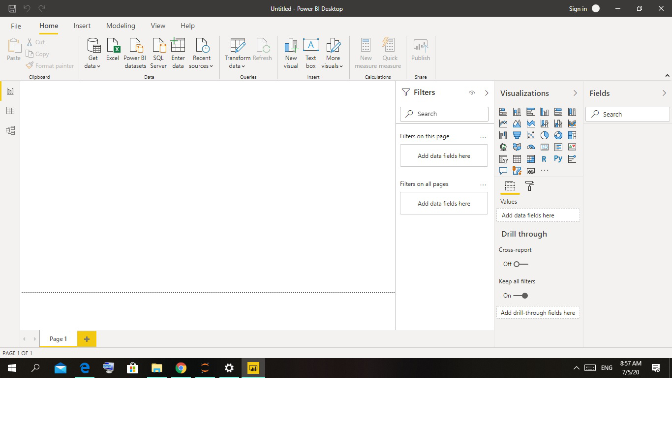
Report View:
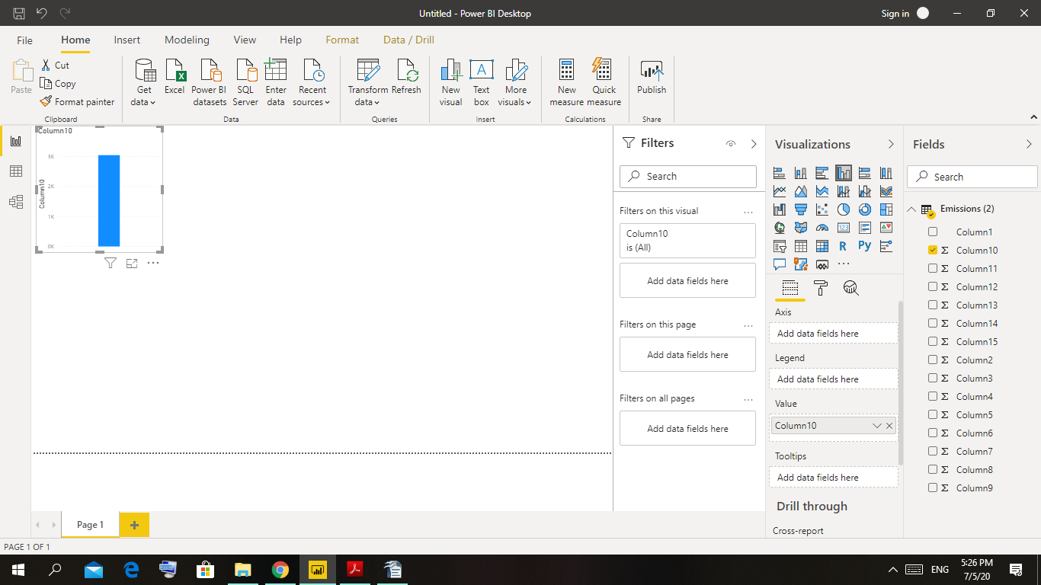

Data View:
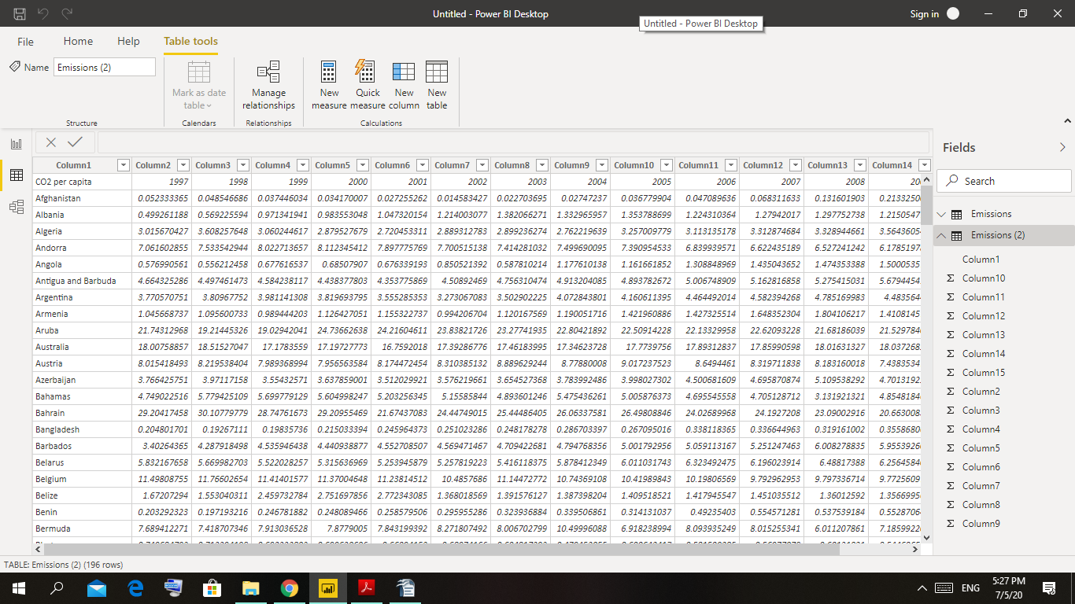
Model View:
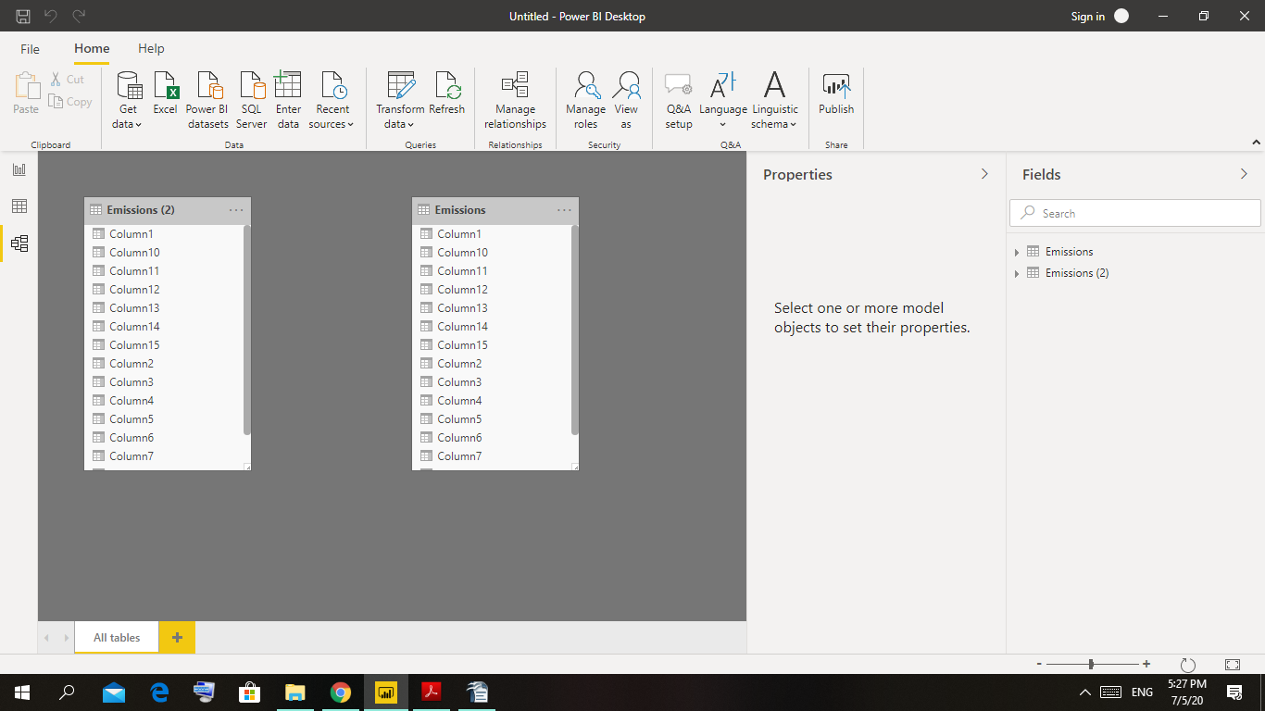

Power Query Editor:
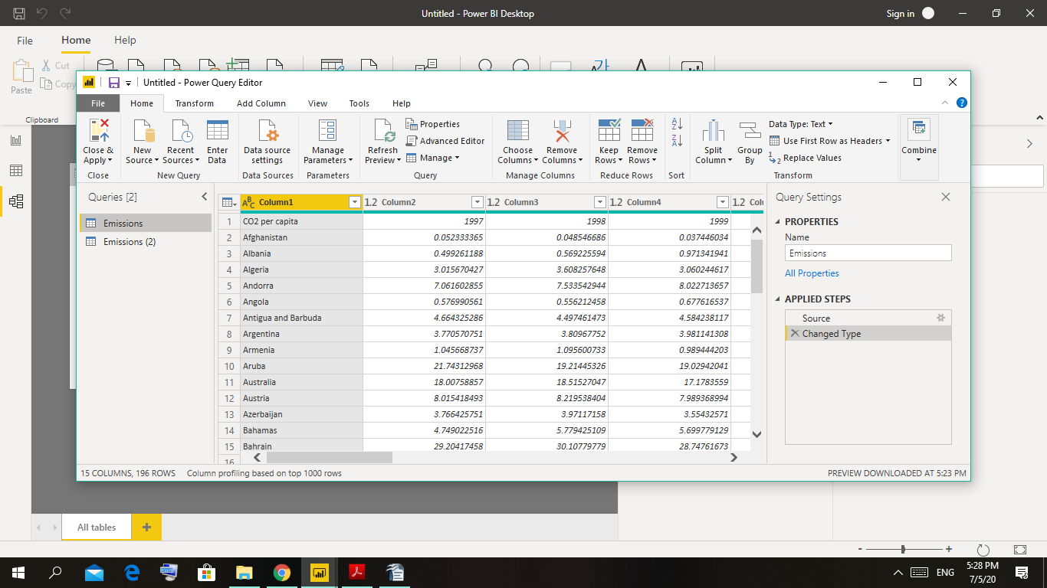

Advance Editor:
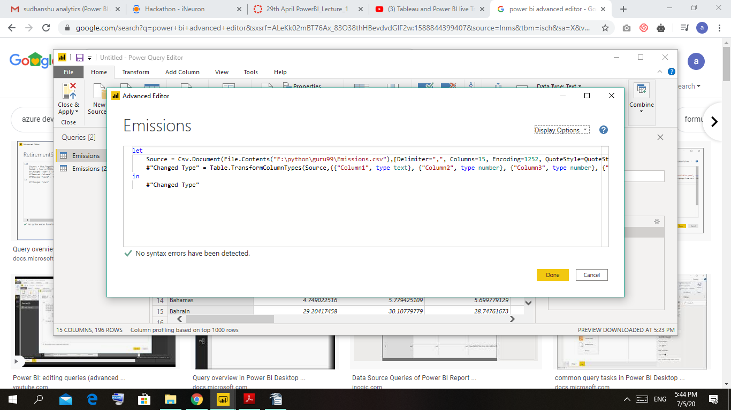

Power BI Desktop:
Power BI Desktop is a free application you install on your local computer that lets you connect to, transform, and visualize your data. Most users who work on business intelligence projects use Power BI Desktop to create reports, and then use the Power BI service to share their reports with others.
Cost : Free
Power BI Pro:
Power BI Pro is an individual user license that lets users read and interact with reports and dashboards that others have published to the Power BI service. Users with this license type can share content and collaborate with other Power BI Pro users.
The Pro plan costs $9.99/user/month. It includes data collaboration, data governance, building dashboards with a 360-degree real-time view and the ability to publish reports anywhere. Users can try a free trial for 60 days before purchasing the subscription.
Power BI premium:
Power BI Premium is a capacity-based offering that includes: Flexibility to publish reports broadly across an enterprise, without requiring recipients to be licensed individually per user. Greater scale and performance than shared capacity in the Power BI service.
The Premium plan starts at $4,995 a month per dedicated cloud compute and storage resource.

